Title: Giving Back to Burma

Photos for Section:

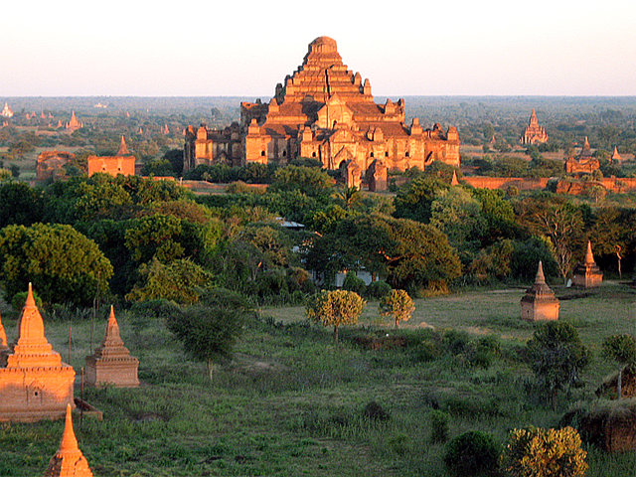

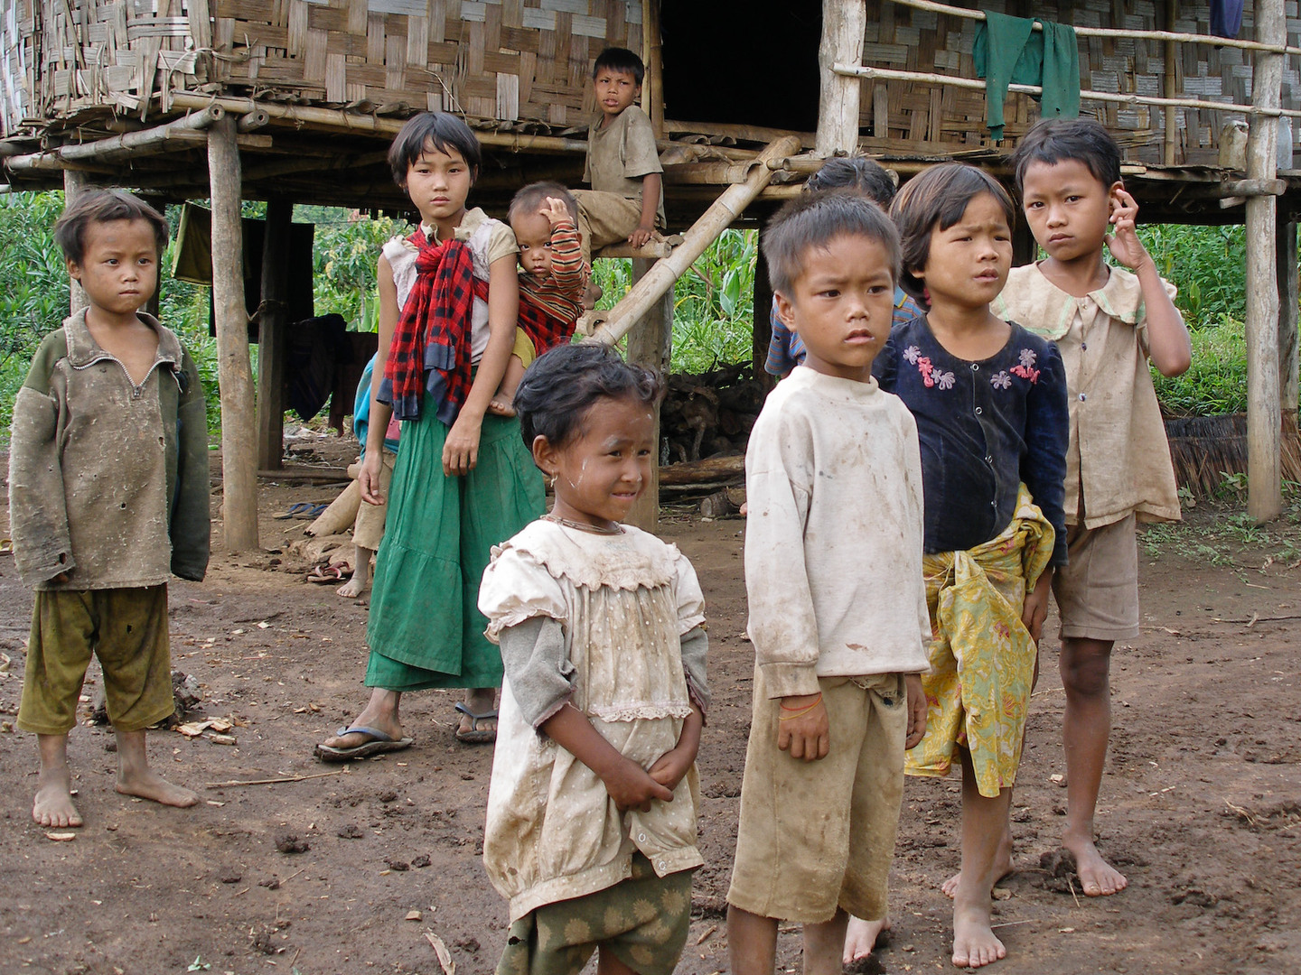

Photo Courtesy of Gusjer.

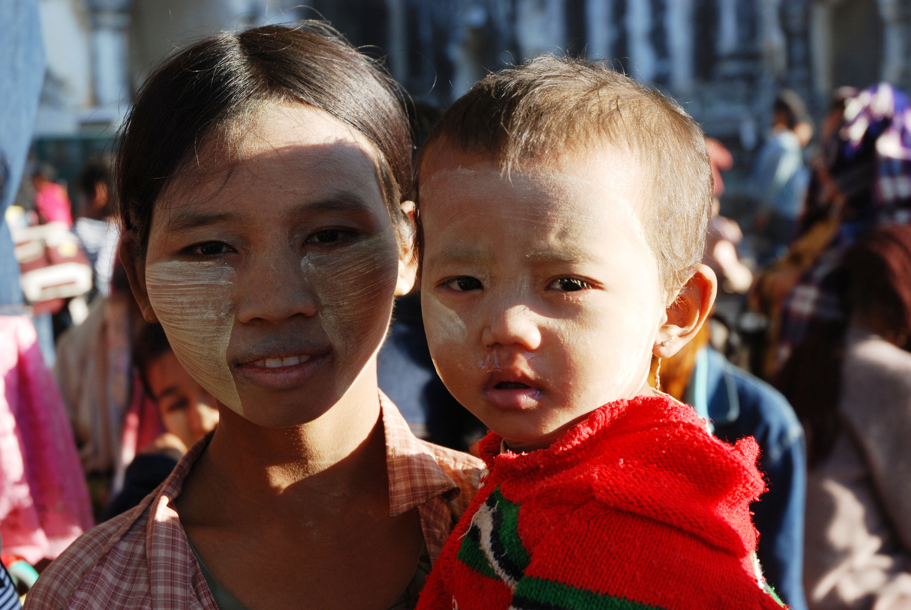

Text:

Phyo cared deeply about (1) children, (2) empowerment through education, and (3) making the most of life by having new experiences. One of his aspirations had been to return to his home country to make education reforms that would empower more children throughout Burma with the gift of knowledge. PN2K hopes to carry through his ambitions through the following projects:

**Partnerships with Local Orphanages**

PN2K has connected with various charity organizations with established presence in Burma and are currently working towards developing projects that would benefit children from local orphanages. Such projects include:

* An "Adopt-a-Child" gift-giving program for the holidays. Volunteers would be asked to create an overseas care package with essential needs (shoes, clothes, school supplies, etc.) for a child and PN2K would coordinate shipment of these packages.
* Scholarships for one-year of primary education in Burma.
* Participation in micro-loan programs to help rural villages develop their schools and buy school supplies.

**Burma Book Drive**

We are in the process of establishing a public lending library system under Phyo's name. Thanks to the efforts of our wonderful volunteers, we have collected more than 100 books for this library. Future steps include shipping the books to Burma and establishing an on-site team to set up the physical library and manage the book collection. We hope to expand this project to student volunteers from the MIT Community in the future.

Not included on website:

*Comment for Local Orphanages section: Will add more specific details about which organization once we have confirmation back from the different groups. Will also need to add later which projects we will be following through with this first year. This section may change drastically in the upcoming weeks.

*I imagine the photos of the children dispersed between paragraphs. Landscape shot up at top of page.